Run 🡪 ng serve and click http:/localhost:4021/

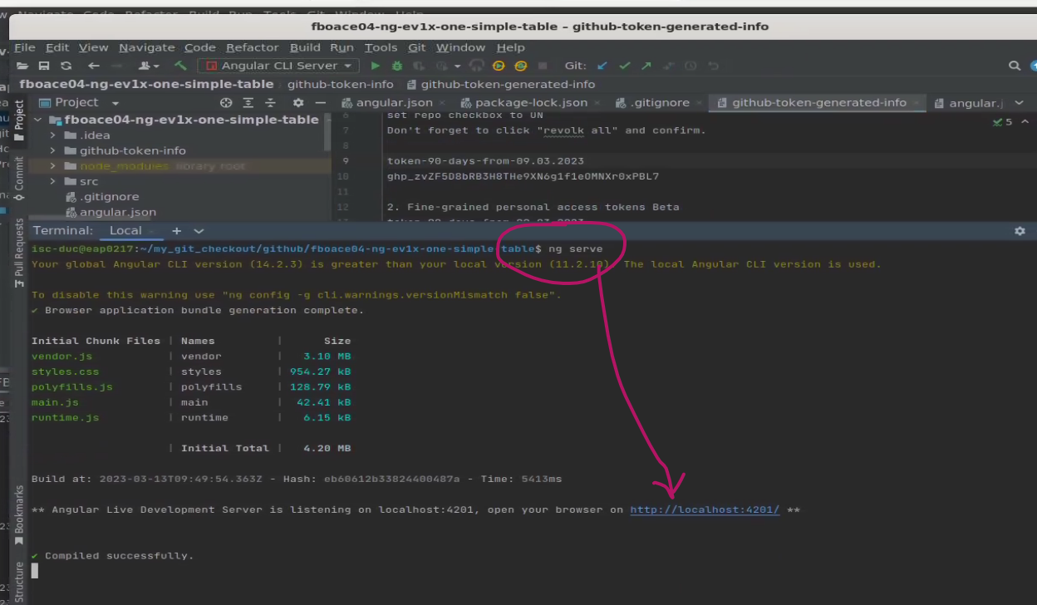

http://localhost:4201/

